**Day 0 – pre production**

**Heartbeast’s Production Point**

To make things a little easier on myself I decided to base my structure and production plan on Heartbeast’s Explore & Exploit theory. In short, it tries to solve the problem of game development getting stuck in prototyping, production, or worse: ***both***.

Read his article [here](https://heartgamedev.substack.com/p/production-point) and keep a lookout for his book – [Production Point](https://heartgamedev.substack.com/p/im-writing-a-book) – whenever that hits the market.

As I already have a decent idea of what kind of gameplay I want to *try* making for the game, it wasn’t hard to split the tasks up into prototyping & production tasks. From there I made an estimate on how long it would take to make the individual components and put them in a basic gantt-like planner I made in Excel.

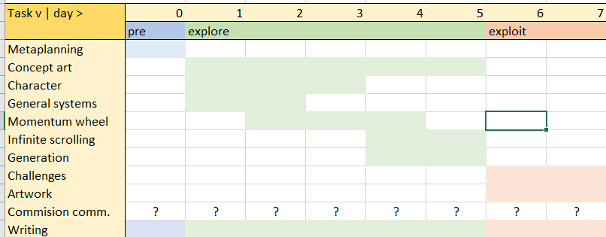

Planning the exploration phase goes against Heartbeast’s theory. Optimally, exploration should be as flexible as possible (scope by doing). Therefore, I have given it as much time as I think I could get away with. Some of the problems I could run into along the way are:

* Concepts I explore don’t work at all and need revising, resulting in adding or removing made systems
* Making the systems in the exploration phase takes too long delaying the exploitation phase
* Tasks I’ve put into the categories don’t fit and end up costing time because they should have been focused on earlier or later in development (possibly hampering other tasks along the way)

I’m going to be as flexible as I can with the time I’ve given myself. If things don’t go as planned in the exploration phase and I never make it to the exploitation phase, then so be it. Hopefully this will still stand as a worthwhile experiment that I’ll be able to bring into future endeavors.

**Time management**

You might have noticed that I simply put numbers on the days in the gantt planner instead of dates or weekdays. This is because I’m setting aside a total of 10 days for the completion of this project – 7 of which I’ll dedicate to the work. I’ll probably need a few days off due to unforeseen circumstances or simply because I want to relax. The blogposts will all come out on days that I’ve decided to work. Hopefully this all works out.

**My tools**

The following is a selection of tools I’ve chosen to use in the production of this project.

[Godot 3.5 (release candidate 8)](https://downloads.tuxfamily.org/godotengine/3.5/rc8/)

Godot 3.5 is very close to stable at this point and has some features I’d like to try out (such as the SceneTreeTween, and scene unique nodes). It is of course possible that there will be a few regressions even in this late release candidate but, I’m not too worried about it because of the short time schedule of this project, and I’m confident in my ability to find workarounds if necessary.

[Hack n’ plan](https://hacknplan.com/)

Hack n’ plan is my Trello-like sprint planner of choice. It has a bunch of features that are gonna aid in the time management and progress tracking of this project (task categories, time estimates, and priorities to name a few). I’ve used it before, and I will use it again.

[Github](https://github.com/) & [Github desktop](https://desktop.github.com/)

Classic solution for version control. In addition to also being a free backup it acts as an additional discipline check for me; I know I’m not focused if I’m committing multiple unrelated changes. I’ve tried git bash but didn’t find it friendly enough.

Other software:

* [Paint tool sai](https://www.systemax.jp/en/sai/) for making concept art and sketches
* [Aseprite](https://www.aseprite.org/) for making tilesets and other pixel art assets
* [Audacity](https://www.audacityteam.org/) for making simple sound effects

**Conclusion:**

With that I feel sorta prepared to start working on the player, systems and maybe some concept art tomorrow. There is more that I could’ve covered here like:

* Godot plugins
* Godot project management
* Plans for music and sound
* Plans for animations and character pixel art

I’ll leave those for future posts if I feel like writing about them.

Cya on day 1.

<https://mega.nz/folder/9qY2GKBL#BvoQMohs3OS_5IH0IjhMRg>